|  |  |
| --- | --- |
| NUIM_logo (Hi-Quality) | **National University of Ireland, Maynooth** Department of Electronic Engineering  EE204 |

## Title: Characteristics of the FET Transistor

## Number: 1

**EQUIPMENT**

2 voltage sources, voltmeters, ammeter, a laboratory lead kit

**OBJECTIVE**

The purpose of this experiment is to understand the function of the MOSFET. In this experiment we take a MOSFET and sketch the device’s input current characteristic for different drain-source voltages and gate-source voltages. The intention is to develop an understanding of the different operating regions for a FET transistor.

### PROCEDURE

**Part 1**

This experiment requires a, 1K resistor and two voltage sources, two voltmeters and an ammeter.

Before connecting any power supply to the circuit, check using either the oscilloscope or the voltmeter the value of the supply you are connecting. It is too late to fix the voltage after connection if it is too high as the transistor may have been damaged by then. Ensure that the ammeter used is the mA and not the uA. Do not use the electronic meter. Ensure that the scale is at 1000, the currents in this experiment will be very high.

In the following circuit, the current will be controlled by the characteristic equation of the MOSFET. There should be no current into the gate of the MOSFET. You can place an ammeter here to check.

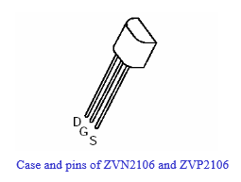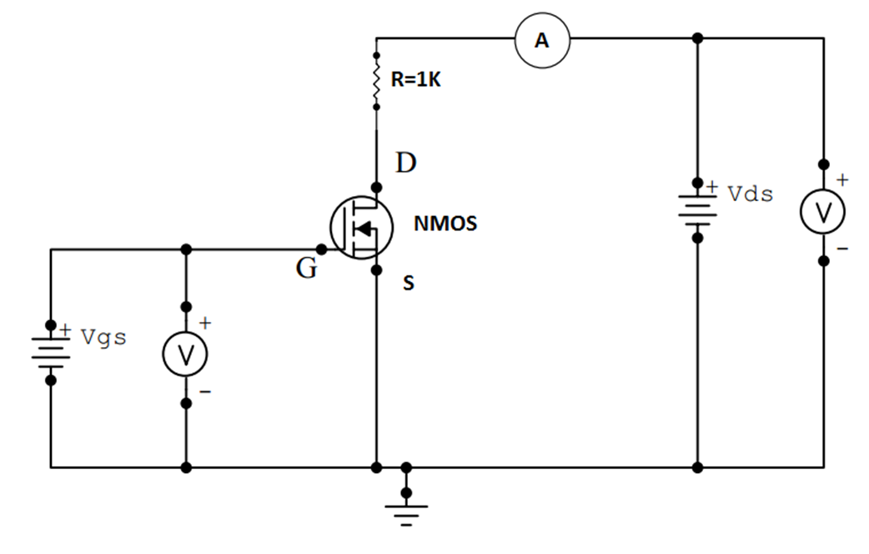

**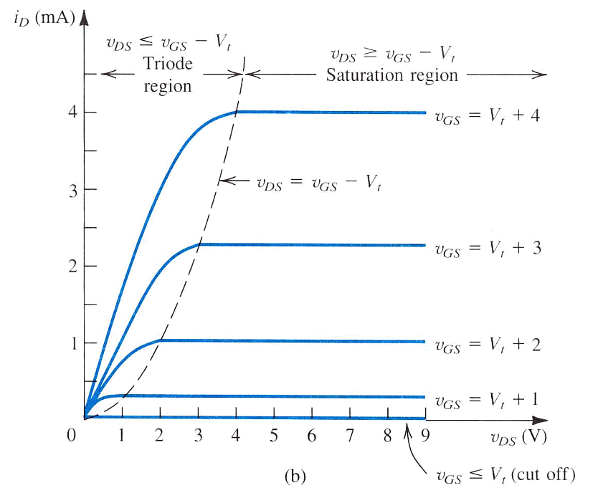**

The transistor should have a threshold voltage around 2 volts but it can vary for different transistors. The intention of the first part of the lab exercise is to construct the V-I graph that is shown above.

To do this, set VDS (the drain source voltage) to 1V and then vary Vgs (the gate-source voltage) until current flows. Identify the gate-source voltage at which current begins to flow. Changing the current scale will allow you to get finer resolution. Note the current will increase rapidly, do not decrease the current scale below 100mA and be prepared to increase the scale if the meter needle is forced all the way over. The voltage that you identify will be the point at which inversion occurs and a small increase on this will generate strong inversion and then strong currents. Increase the drain-source voltage until you get to 5 volts, you can take 1 volt steps once you have crossed the threshold voltage. At all points record the VDS voltage and the drain current.

Repeat the current measurements for the following values of VGS of 0, 0.5, 1.0, 1.5, 2, 3, and 5 volts. Your results will look something like the following table

|  |  |  |  |  |  |  |
| --- | --- | --- | --- | --- | --- | --- |
|  | VDS = 0 | 1 | 2 | 3 | 4 | 5 |
| VGS = 0 | ID=0 |  |  |  |  |  |
| VGS = 0.5 |  |  |  |  |  |  |
| VGS = 1.0 |  |  |  |  |  |  |
| VGS = 1.5 |  |  |  |  |  |  |
| VGS = 2.0 |  |  |  |  |  |  |
| VGS = 3.0 |  |  |  |  |  |  |
| VGS = 5.0 |  |  |  |  |  |  |

1. In your report, please add a graph of your results and discuss it's similarity and differences with the ideal chart from the previous page.
2. Now calculate the resistance (VDS/ID) and graph this in your report for different values of VDS and VGS. This is similar to the last graph except now R is on the Y axis and not ID
3. What is Vt for your particular FET ?

**NOTE: real systems are never as smooth or as simple as the ideal charts, so draw what you measured. It should be broadly similar at the extremes, but the middle transition region may be different.**

**Part 2**

Using the same circuit, for VGS=3.0 (or whatever gives you a good curve), measure the current ID that flows for values of VDS steps of 0.1 volts. Instead of taking a LOT of measurements, take measurements for values of VDS in the ranges 0 to 1 volts and VDS from 3 volts to 4 volts. Feel free to do it for wider ranges.

One measure of resistance is given by the ratio of the increase in current over an increase in voltage. Work out the resistance given by ratio of the increase in current (∆ID) for each 0.1 volt increase in voltage dropped (∆VDS). Chart these results.

On the same chart, plot the resistance calculated from the total voltage (VDS) dropped divided by the total current (ID) flowing. (hopefully will look similar to the graph from PART1 for the same value of VGS).

### REQUIRED RESULTS IN REPORT

To be uploaded via moodle before the next laboratory

Please transcribe the results of the questions in the order of experiment

Your report should have the following structure

* A brief introduction showing you know what the lab is about (3-4 lines MAX)
* For each section you need the following
  + - A drawing of the circuits used
    - Your results
    - Comments and opinions on results or methods used.
* Conclude your report with a summary section which may include any additional conclusions you may have.

Late reports can be emailed to me but will incur penalties of 10% per day (or part of a day, weekends are counted the same as weekdays).

|  |
| --- |
| **Marks will be deducted for poorly presentation, poorly written reports.**  **Marks will only be awarded for sections completed.** |